1.

(آ)

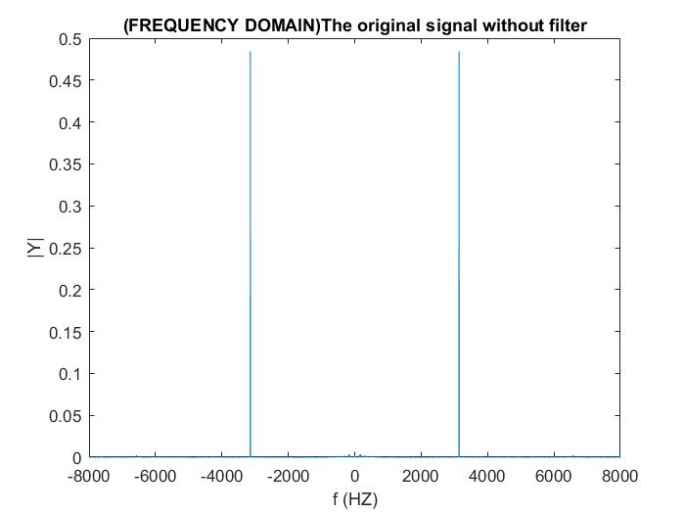

*Here we plot our original signal and as we can see the noise frequency is about 3000Hz and that our noise is single tone noise with only one frequency.*

(ب)

*Filter designer*

*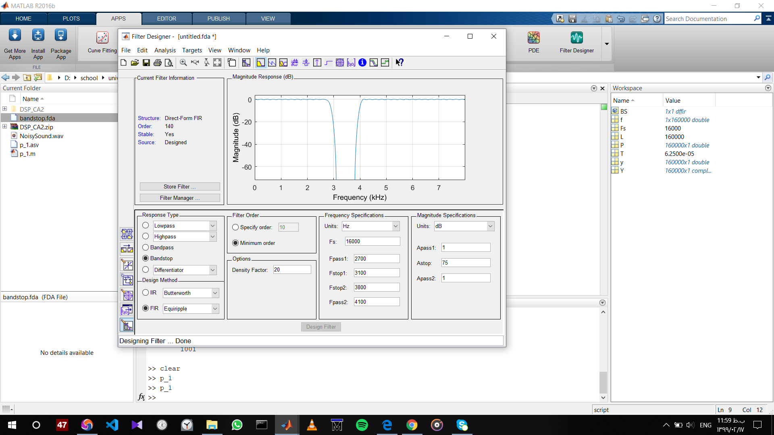*

*Here we want to analyze three filter*

*1.Band-stop filter*

*2.Low-pass filter*

*3.High-pass filter*

**

*You can see their mat file in mat folder.*

*Now we want to see their frequency response:*

**

*1.Band-stop*

*2.Low-pass*

**

*3.High-pass*

*SOUND*

*1.Band-stop*

*After filtering with BS filter we can see that our noiseless sound is an audio without any noise*

*2.Low-pass*

*After filtering with a LP filter due to omitting High frequency we hear a Low pitched voice.*

*3.High-pass*

*After filtering with a HP filter due to omitting Low frequency we hear a High pitched voice.*

*PLOTTING IN TIME DOMAIN*

*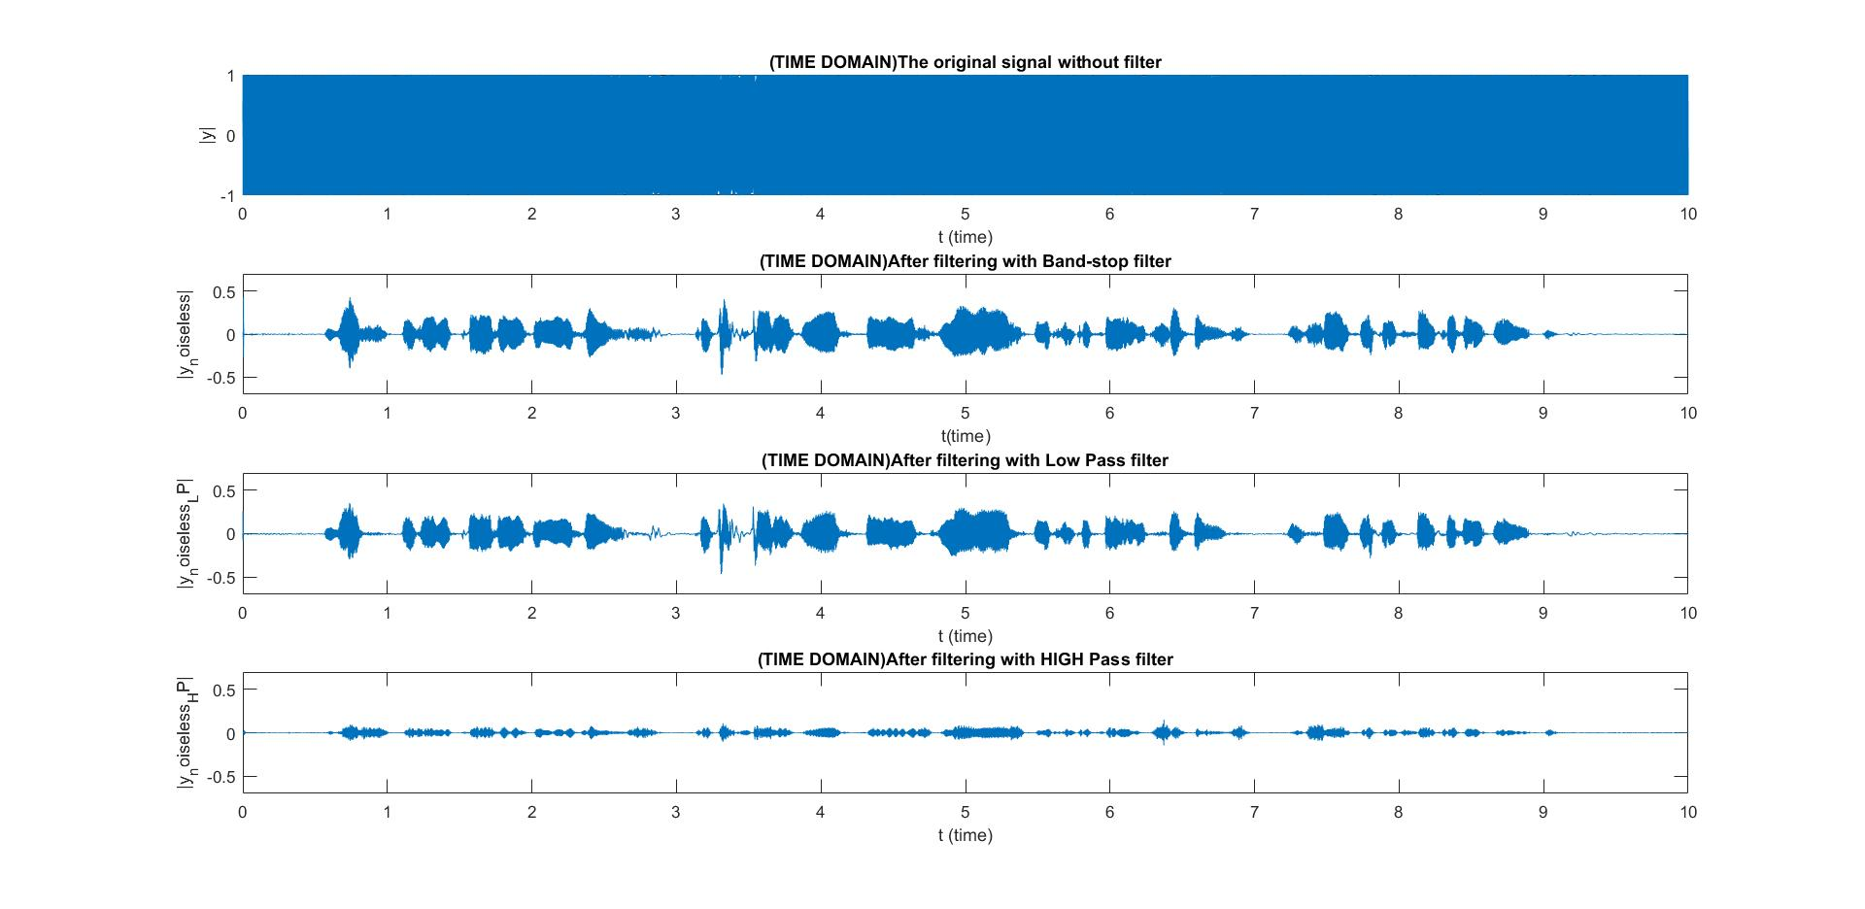as we can see here in the plot Low-pass filters makes our signal smother than before but High-pass filters will show us the variation of our signal.*

*PLOTTING IN FREQUENCY DOMAIN*

*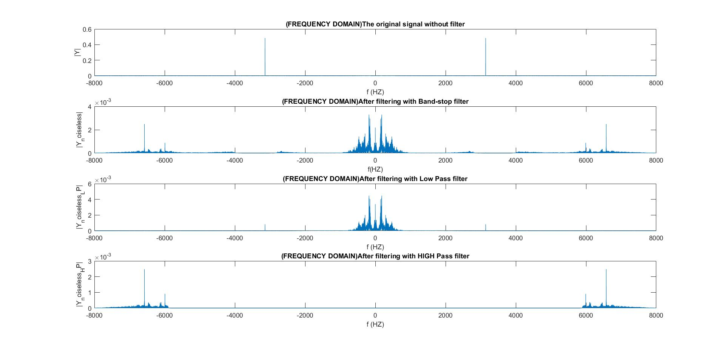We can clearly see the omission of high or low frequencies after filtering.*

*Part TWO*

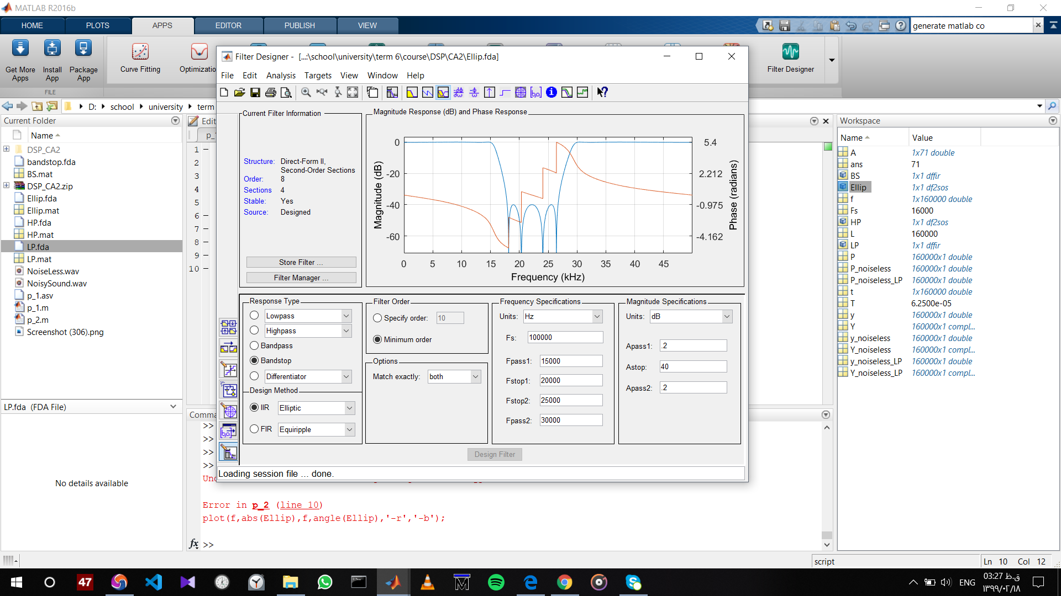

*Magnitude response and phase response*

*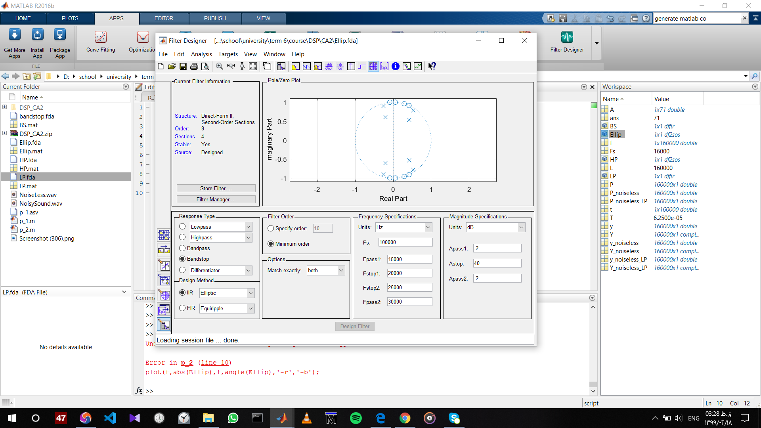*

*Pole zero plot*

*We can see that it’s a stable causal system.*

*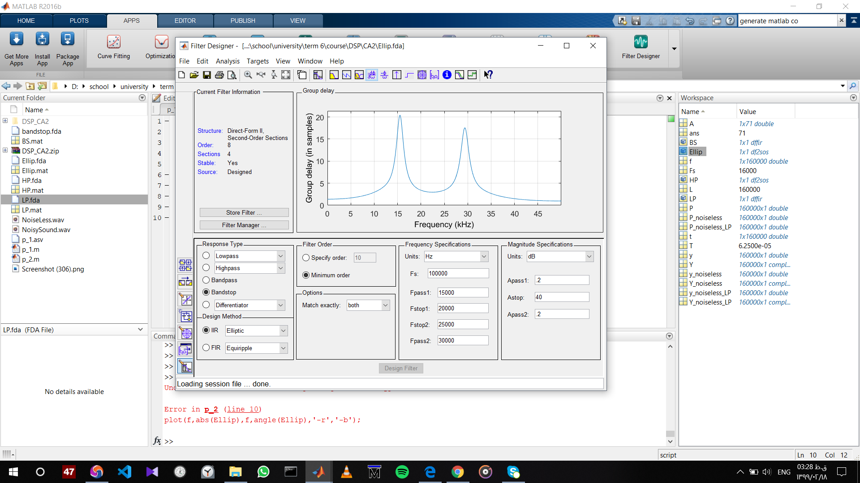*

*Group delay*